ASSIGNMENT 12

Que 1 Write a query that selects all customers whose rating are equal to or greater than any of serres
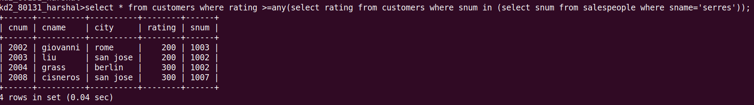

Que 2. Write a query using any or all that will find all salespeople who have no customers located in their city,

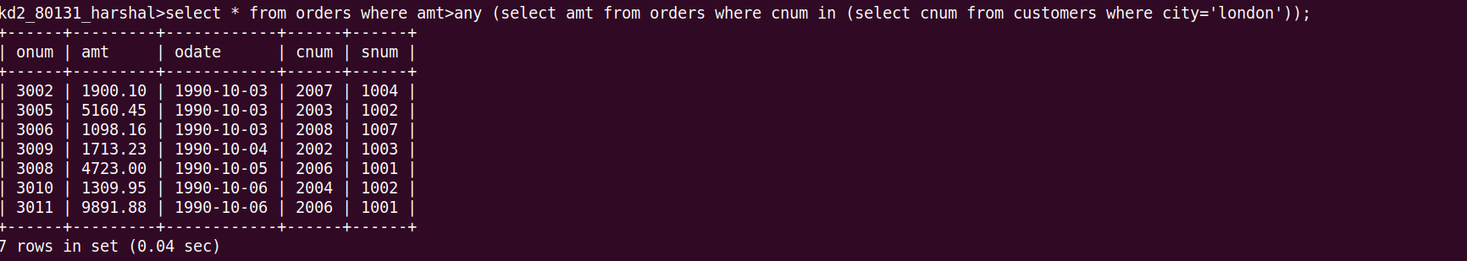
Que 3. Write a query that selects all orders for amounts greater than any for the customers in london.

Que 4. Write the above query using min or max.


